

Manual Testing actiTime



Project submitted by:-

Team leader:- Gajula Manjula

Team members:-

*Devathi Anjalirani

*Dasari Guruprasadyadav

*Ganta Praneetha

*Gangarapu Maneesha

**actiTime Manual Testing**

actTime is a web site deals with product for time tracking software for cost effective projects.actTime boosts performance,track work progress and don’t leave any billable second untracked and records billable hours for a project resource for easy monitoring the work hours.

We can generate reports based based on hours logged and also,we can integrate with other platforms like google calender,Zapier etc.



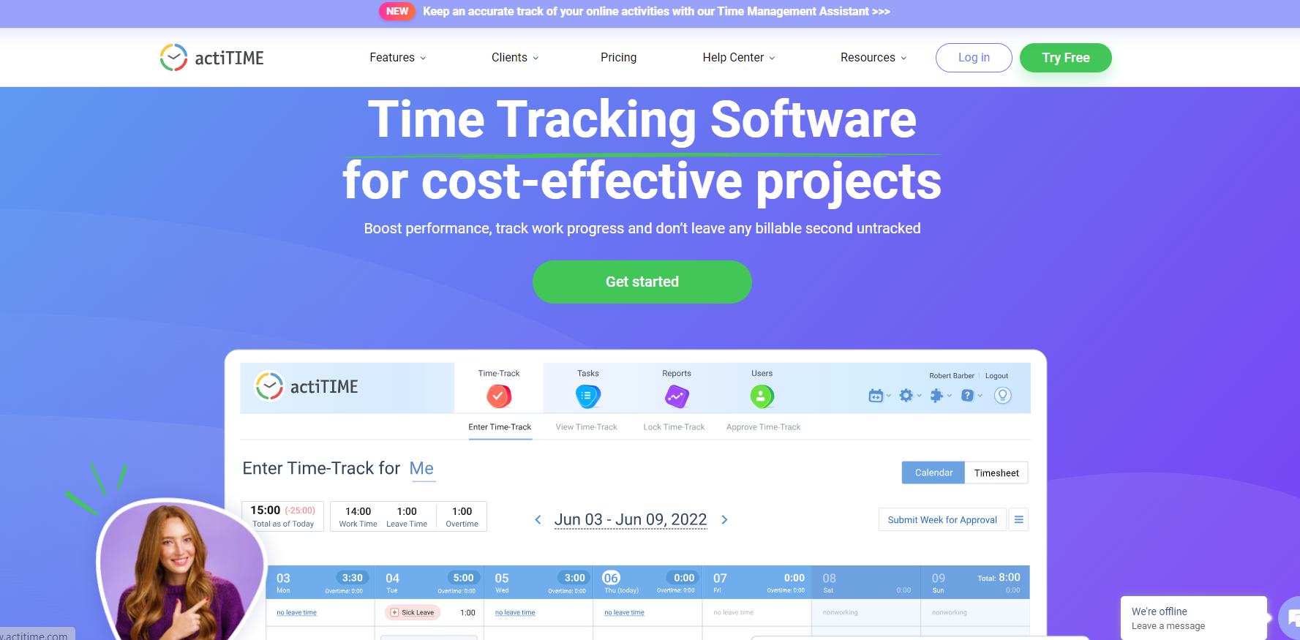

Link: https://www.actitime.com

**Project Flow:**

* User can register and use the actiTIME application for free for 30days
* User can register once and login using credentials and security code received to email provide at the time of registration
* User can chat with customer representative for any queries
* User can also generate reports from actiTIME application about logging hours

# Modules Structure:

We have different modules in this all the modules are listed below,

* Features
  + Time Tracking
  + Billing & Invoicing
  + Customer Care
  + Reports & Data Analysis
  + Team Management
  + Integrations
  + Project Tracking
  + Workflow
  + Product Datasheet PDF
  + See all features link
* Clients
  + Architecture
  + Education
  + IT
  + Consulting
  + Engineering
  + Small Business
  + Design
  + Healthcare
  + Case studies
  + See all industries link
* Pricing
* Help Center
  + User Guide
  + FAQ
  + Admin Guide
  + How-to-Videos
  + API Guide
  + actiTIME Tips
* Resources
  + Guides by topic
  + Time Tracking
  + Project Costs
  + Guides by Industries
  + For Developers
  + For Architects
* Login

**Milestone 2: Clients Module**

Under Clients Module we have different clients for whom actiTIME application is suitable for and it also shows different categories of job roles who get benefit from

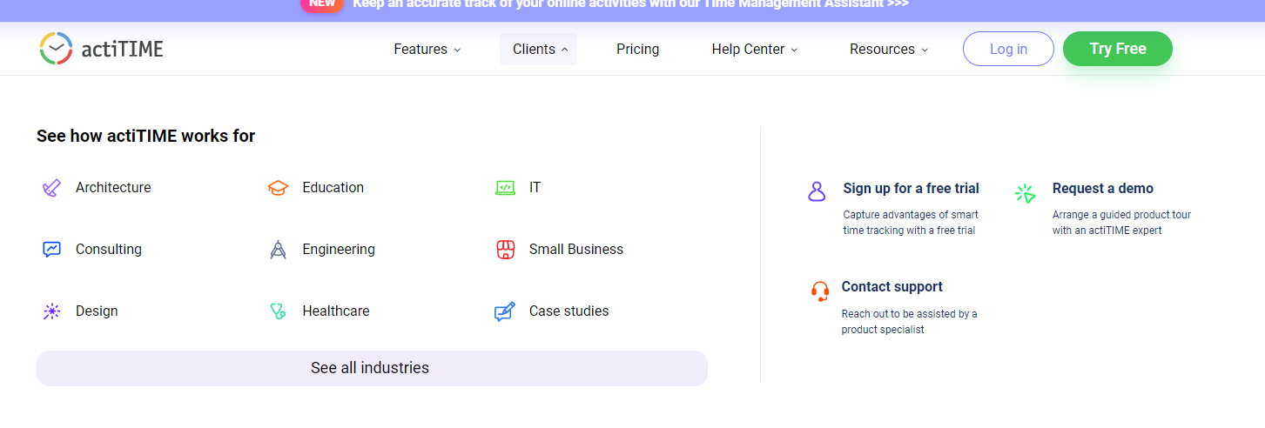

Link: <https://www.actitime.com/>

## Activity 1: Verifying architects page functionality and text in terms of color ,font ,spacing between words, design and whole representation

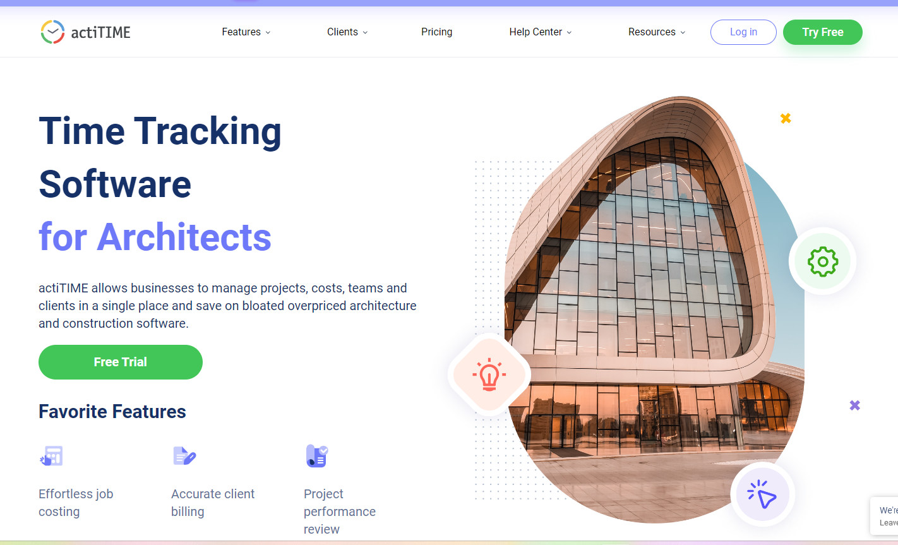

Link: <https://www.actitime.com/testimonials/timesheet-for-architects>











**Conclusion**

The **actiTIME** manual project provides a framework for automating various tasks within the **actiTIME** web application using Python, Selenium, and Pytest. With this documentation, you should be able to set up the project, execute tests, and extend/customize it according to your needs.